*Wall Breaker*

# Overview/Theme

## Idea Summary

It’s a simple hyper casual game in which our character is Juggernaught (from X-Men). He is running infinitely inside interior of houses in a row. There will be two modes of this character 1) Charging 2) Running. By default he is in running mode but if player press button A then he is in charging mode Whenever a wall/obstacle comes in front he breaks it in charging mode else he dies if he is in running mode. The player is moving continously and he has to be aware of what’s coming in front.

## Goal

To reach the end of the level and survive all the walls/obstacle using the Juggernaught power.

# Mock Ups

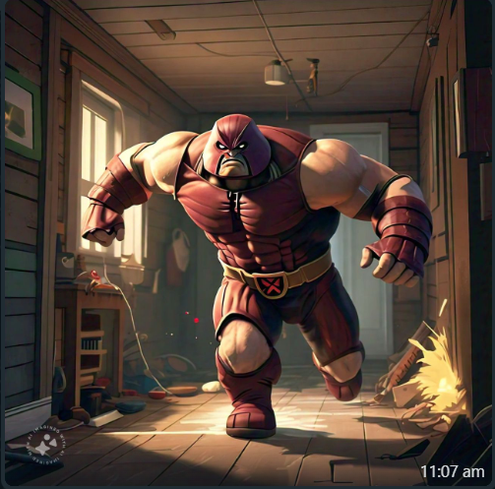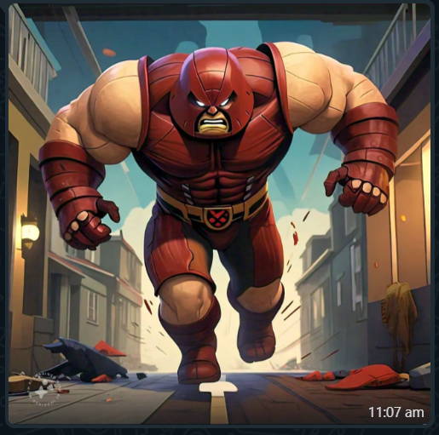

# References

https://www.youtube.com/watch?v=3FzaUY80MIQ

# Art Style (check any number of boxes that apply)

* 2.5D
* 3D
* Cartoon
* Cell Art
* Low Poly
* Isometric

# Look & Feel / Camera

* Over The Shoulder

# Mechanic

## Controls

* Landscape
* Single Touch
* Tap

Progression

* Level Based